**EXPERIMENT-5**

Bhavdeep Singh

Cse 1 - 01713202717

# AIM:

# Study and implement the Multinomial Naive Bayes on spam-ham-dataset.

# ALGORITHM:

1. In the first step, feature engineering, we focus on extracting features of text. We need numerical features as input for our classifier.
2. In the non-naive Bayes way, we look at sentences in entirety, thus once the sentence does not show up in the training set, we will get a zero probability, making it difficult for further calculations.
3. In the final step, we are good to go: simply calculating the probabilities and compare which has a higher probability

# PROGRAM CODE SNIPPET:

## LOADING DATA SET:

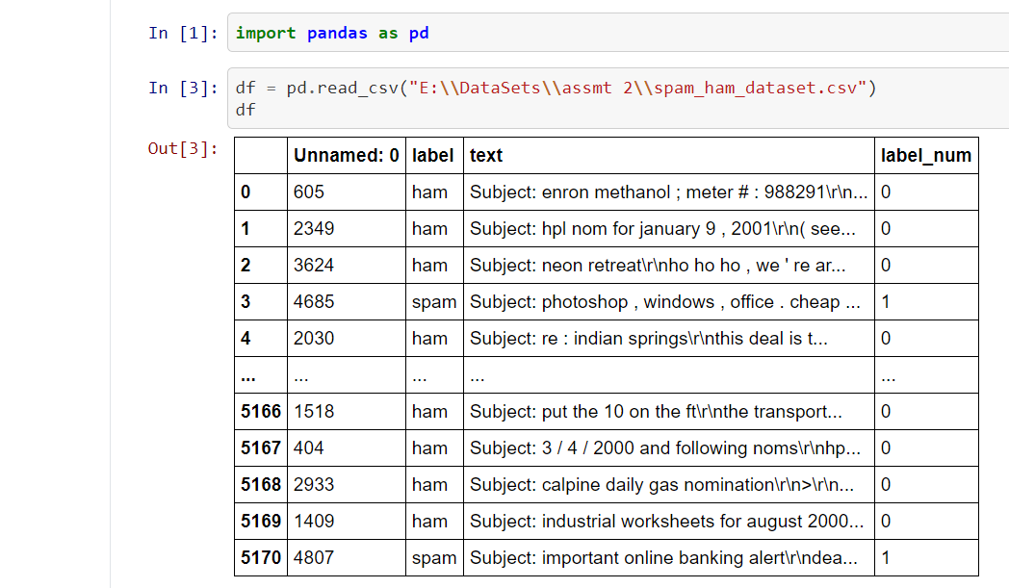

## PREPROCESSING:

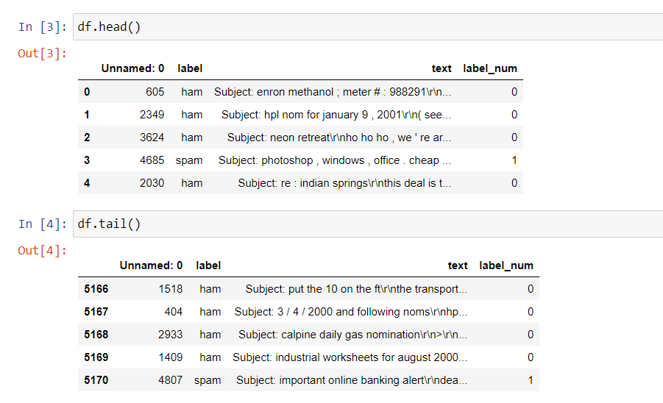

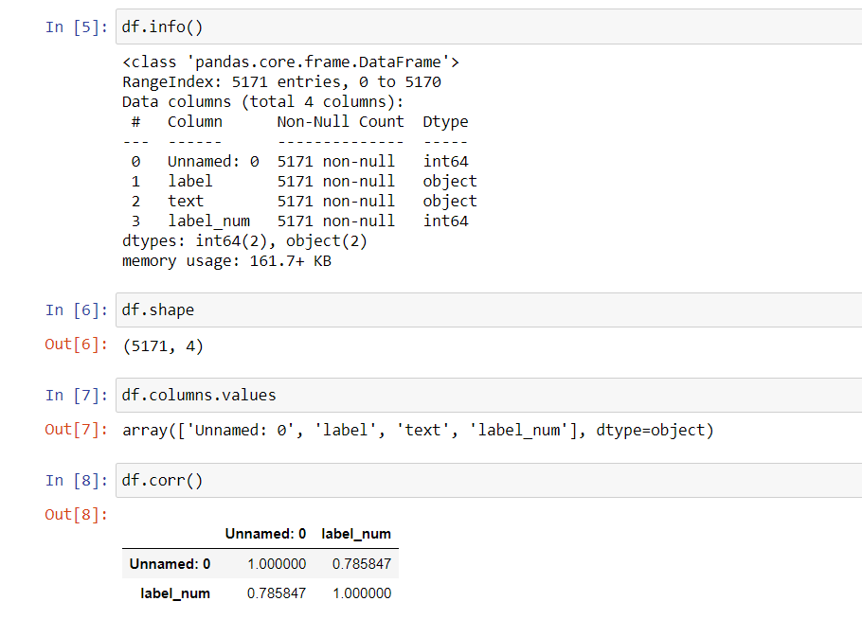

## VISUALIZATION:

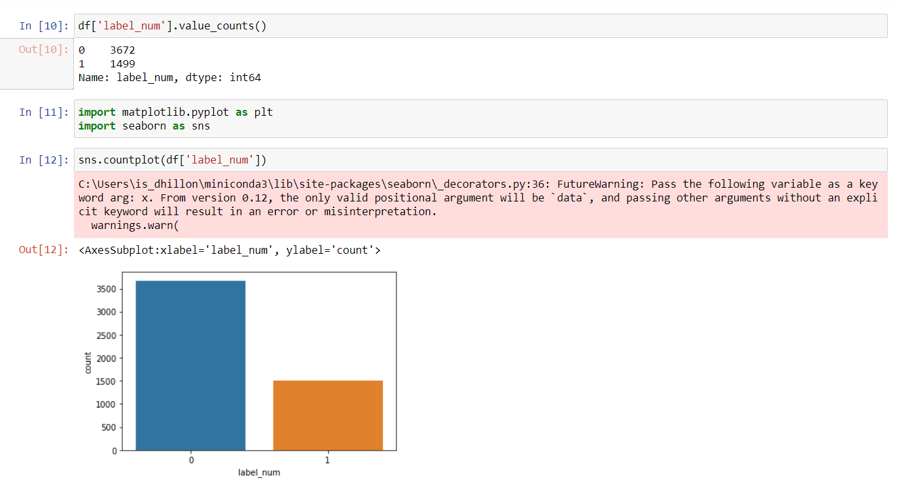

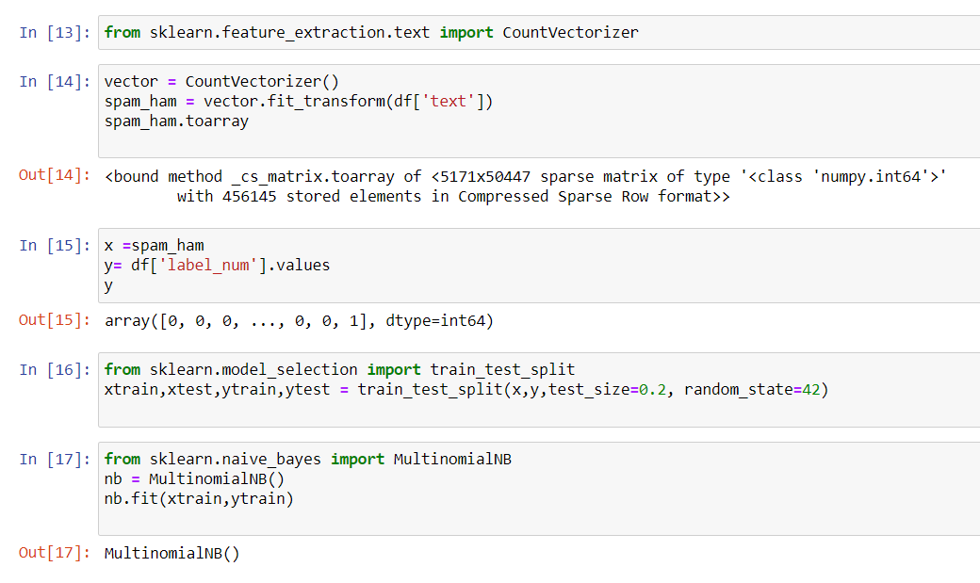

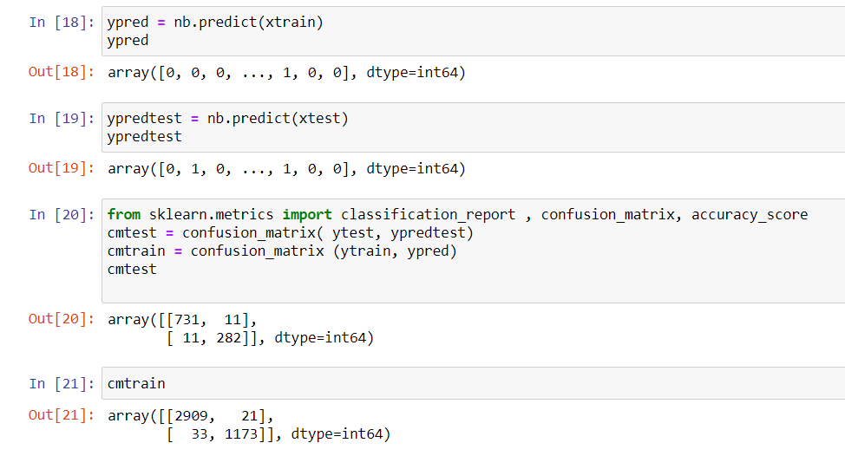

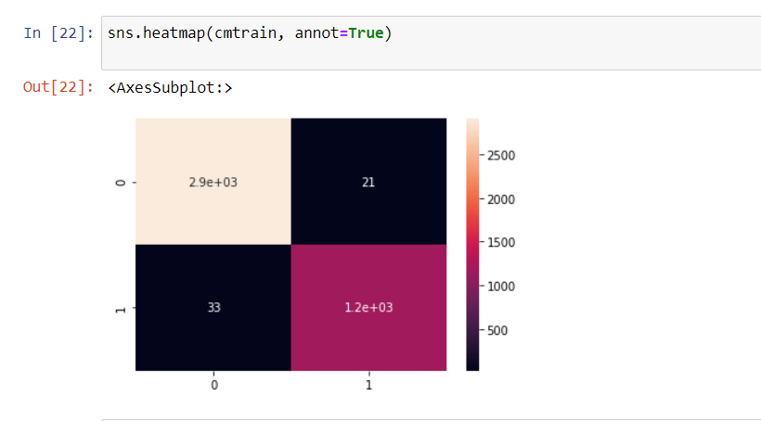

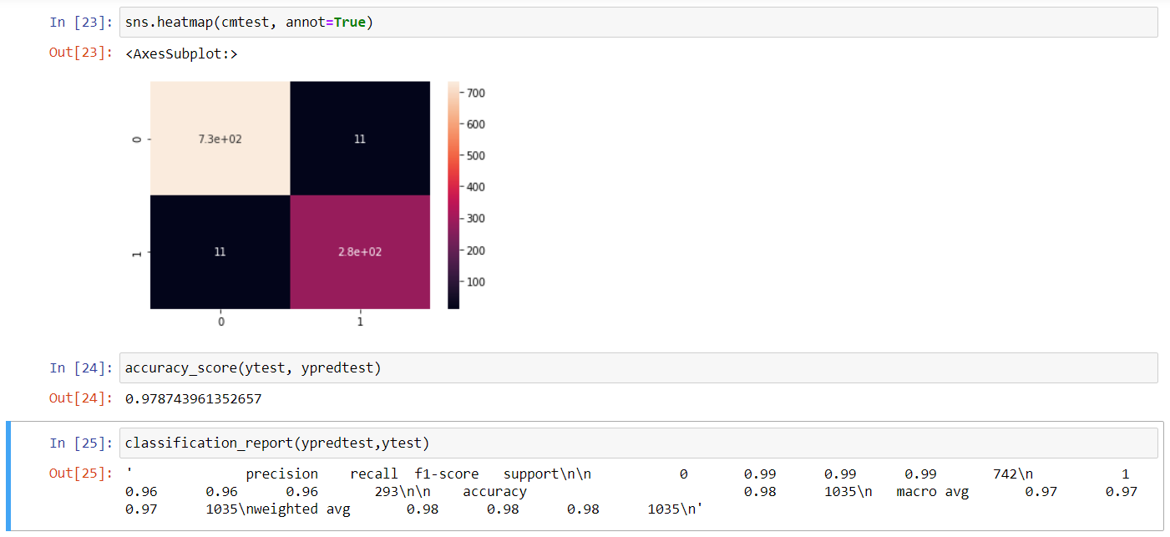

# GITHUB LINK:

https://github.com/Bhavdp-Singh/Python-Lab/blob/main/ML%20LabExp5.ipynb